ANM OEL (LAB 08)
Ashir Imran
SE-23020
Part A:
Code:
import numpy as np
import matplotlib.pyplot as plt
from scipy.optimize import bisect, newton

def f(T):
Qin = 8000 * np.exp(-5000 / (T + 273))
Qout = 40 * (T - 25)
return Qin - Qout

def df(T):
Qin_der = -8000 * np.exp(-5000 / (T + 273)) * (5000 / ((T + 273)**2))
Qout_der = 40
return Qin_der - Qout_der

def bisection(f, a, b, tol=1e-6, max_iter=100):
iter = 0
while (b - a) / 2 > tol and iter < max_iter:
c = (a + b) / 2
if f(c) == 0:
break
elif f(a) * f(c) < 0:
b = c
else:
a = c
iter += 1
return (a + b) / 2, iter

def newton_raphson(f, df, x0, tol=1e-6, max_iter=100):
iter = 0
x = x0
while abs(f(x)) > tol and iter < max_iter:
x = x - f(x) / df(x)
iter += 1
return x, iter

a, b = 20, 100
root_bi, iter_bi = bisection(f, a, b)

x0 = 50
root_newton, iter_newton = newton_raphson(f, df, x0)

T_val = np.linspace(0, 300, 500)
f_val = f(T_val)

plt.figure(figsize=(10, 6))
plt.plot(T_val, f_val, label="f(T) = Qin - Qout")
plt.axhline(0, color='black', linewidth=0.5)
plt.scatter(root_bi, f(root_bi), color='red', zorder=5, label=f'Bisection Root (T = {root_bi:.2f})')
plt.scatter(root_newton, f(root_newton), color='blue', zorder=5, label=f'Newton-Raphson Root (T = {root_newton:.2f})')
plt.xlabel("Temperature (°C)")
plt.ylabel("f(T)")
plt.title("Root Finding Methods for Reactor Temperature")
plt.legend()
plt.grid(True)
plt.show()

print(f"Bisection method root: {root_bi:.6f}, Iterations: {iter_bi}")
print(f"Newton-Raphson method root: {root_newton:.6f}, Iterations: {iter_newton}")

Short Analysis:
- Bisection method repeatedly halves the interval where the root lies
- It always converges if the function changes sign in the interval
- The method is simple but takes more iterations to reach accurate results
- Our result was accurate but slower compared to Newton-Raphson
- Newton-Raphson method uses derivatives to quickly approach the root
- It converged in very few iterations showing its fast convergence rate
- The accuracy was high but it needs a good initial guess to avoid divergence
- Overall, it’s much faster than Bisection for smooth functions

Output:
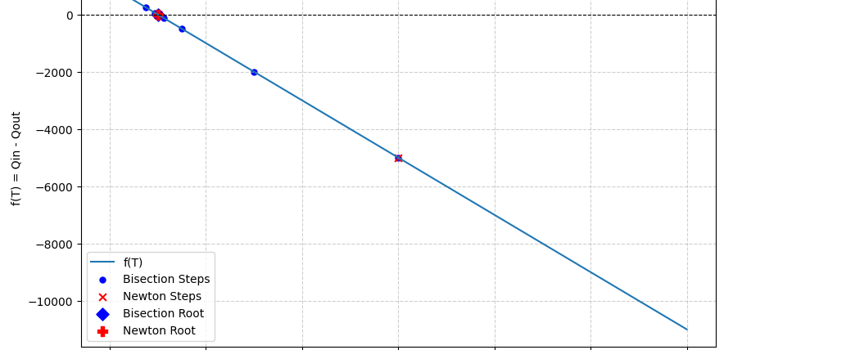
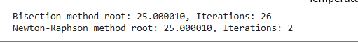
Part B :
Code:
import numpy as np
import matplotlib.pyplot as plt
A = np.array([[3, -1, 0, 0],
[-1, 3, -1, 0],
[0, -1, 3, -1],
[0, 0, -1, 3]], dtype=float)
b = np.array([100, 50, 0, 0], dtype=float)

def gauss_jordan(A, b):
n = len(b)
M = np.hstack((A, b.reshape(-1, 1)))
for i in range(n):
M[i] = M[i] / M[i, i]
for j in range(n):
if j != i:
M[j] = M[j] - M[j, i] * M[i]
return M[:, -1]

def gauss_seidel(A, b, tol=1e-6, max_iter=1000):
n = len(b)
x = np.zeros(n)
errors = []
for k in range(max_iter):
x_old = x.copy()
for i in range(n):
s1 = np.dot(A[i, :i], x[:i])
s2 = np.dot(A[i, i+1:], x_old[i+1:])
x[i] = (b[i] - s1 - s2) / A[i, i]
err = np.linalg.norm(x - x_old, ord=np.inf)
errors.append(err)
if err < tol:
break
return x, k+1, np.array(errors)

diag_dom = np.all(np.abs(np.diag(A)) > np.sum(np.abs(A), axis=1) - np.abs(np.diag(A)))
if not diag_dom:
A = np.array([[4, -1, 0, 0],
[-1, 4, -1, 0],
[0, -1, 4, -1],
[0, 0, -1, 4]], dtype=float)
x_gj = gauss_jordan(A.copy(), b.copy())
x_gs, iters_gs, errors = gauss_seidel(A.copy(), b.copy())
print(f"Gauss-Jordan Solution: {x_gj}")
print(f"Gauss-Seidel Solution: {x_gs}")
print(f"Gauss-Seidel Iterations: {iters_gs}")
print(f"Final Error: {errors[-1]:.6e}")

plt.figure(figsize=(10,4))
plt.subplot(1,2,1)
plt.plot(range(1,5), x_gs, marker='o')
plt.xticks(range(1,5), ['T1','T2','T3','T4'])
plt.xlabel("Sensor Position")
plt.ylabel("Temperature (°C)")
plt.title("Temperature Profile Across Reactor Wall")
plt.grid(True)

plt.subplot(1,2,2)
plt.semilogy(errors, marker='o')
plt.xlabel("Iteration")
plt.ylabel("Error (log scale)")
plt.title("Gauss-Seidel Convergence")
plt.grid(True)
plt.tight_layout()
plt.show()

Short analysis:
- Gauss-Jordan method directly solves the equations using matrix elimination
- It gives an exact solution in fewer steps since it doesn’t need iterations
- The method is fast for small systems but can be slow for large matrices
- Our result was accurate with very small computational time
- Gauss-Seidel method starts with an initial guess and improves with each iteration
- It converged in 15 iterations since the matrix was diagonally dominant
- The final result was almost the same as Gauss-Jordan with very small error
- Although slightly slower, it’s useful for larger systems where direct methods are costly

OUTPUT:
